Hi,

1. -
2. I don´t get the problem. You are allowed to open the file in xls format. What do you expect to happen in the dialog?
3. To activate the configuration on CE Target do the following steps:
   1. The Execute  “TcEventConfigurator.exe” in “C:\TwinCAT\3.1\Components\TcEventLogger\EventConfigurator\”
   2. Create events (SourceId = “Groups”, EventId = EventId).
   3. Copy Event file (\*.ecpx) to target system “\Hard Disk\TwinCAT\3.1\Target\Resource\”
   4. On target the file „TcEventSourceLocation.xml“ inside same folder (“\Hard Disk\TwinCAT\3.1\Target\Resource\“) has to be modified.  SourceIds have to be defined like: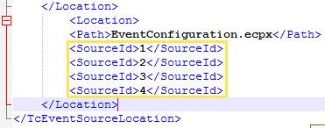  
        
      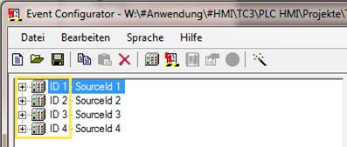
   5. Safe XML File and restart system
4. Ok, behavior is reproducible, but If you start the application and open the file everything works well.